Linux Commands & System Administration Handbook

Week 3 GRC Portfolio Project

Company
ABC Solutions Pvt. Ltd.

Prepared By
Durva Amin

Version
1.0

Date
15 August 2026

Review Date
15 November 2026

Table of Contents
Purpose 4
Scope 4
Linux Overview 4
What is Linux? 4
Linux Distributions 4
Linux in Security 4
Linux File System 4
Linux File System Structure 4
Important Directories 5
Absolute and Relative Paths 5
Users and Groups 5
Linux Users 5
Linux Groups 6
User and Group Management 6
File Permissions 6
Understanding File Permissions 6
Permission Types 6
Permission Categories 6
Reading Linux Permissions 6
Numeric Permission Values 7
chmod and chown 7
chmod 7
chown 7
chmod vs chown 7
Security Relevance 8
Linux Commands 8
File and Directory Commands 8
File Viewing and Searching Commands 8
System Information Commands 8
Network Commands 9
User and Permission Commands 9
Linux Processes 9
What is a Process? 9
Process States 9
Process Management Commands 9
Security Relevance 10
Linux Logs 10
What are Linux Logs? 10
Common Log Locations 10
Viewing Logs 10
Security Relevance 11
Linux Security Controls 11
User and Access Control 11
File Permission Controls 11
System Updates 11
Firewall 11
Logging and Monitoring 11
Security Controls Table 12
Security Recommendations 12
Access Management 12
File and Permission Management 12
Patch Management 12
Firewall Configuration 12
Logging and Monitoring 13
Practical Exercises and Evidence 13
Exercise 1: File and Directory Navigation 13
Exercise 2: File Creation and Management 13
Exercise 3: File Permissions 14
Exercise 4: Users and Groups 14
Exercise 5: Processes and System Information 15
Conclusion 16
Version History 16
References 16

Purpose
This document provides a basic introduction to Linux operating systems, file systems, users and groups, file permissions, common Linux commands, processes, logs, and security controls. It is intended to support beginners in understanding basic Linux concepts relevant to cybersecurity and Governance, Risk, and Compliance (GRC).

Scope
This handbook covers basic Linux concepts and system administration topics studied during Week 3. It includes the Linux file system, users and groups, file permissions, chmod, chown, common Linux commands, processes, logs, and basic security controls. The practical exercises demonstrate basic Linux command usage in a controlled learning environment.

Linux Overview

What is Linux?
Linux is an open-source operating system based on the Unix operating system principles. It is widely used on servers, personal computers, cloud platforms, and security systems. Linux provides users with tools to manage files, users, processes, applications, and system resources.

Linux Distributions
A Linux distribution is a complete operating system built around the Linux kernel. Different distributions provide different software packages, tools, and desktop environments. Common examples include Ubuntu, Debian, Fedora, and Kali Linux.

- Ubuntu – Commonly used for desktops, servers, and learning.
- Debian – Known for stability and widely used on servers.
- Fedora – Provides newer technologies and features.
- Kali Linux – Designed for cybersecurity and penetration testing.

Linux in Security
Linux is widely used in cybersecurity because it provides strong command-line tools, user and permission management, system logs, and process controls. Security professionals may use Linux for server administration, security monitoring, vulnerability assessment, and other security-related activities

Linux File System

Linux File System Structure
The Linux file system is organised as a hierarchical structure that starts from the root directory, represented by /. All files and directories are located under the root directory. Linux uses directories to organise system files, user files, configuration files, applications, and temporary data.
/
├── home
├── etc
├── var
├── tmp
├── usr
├── bin
└── root

Important Directories
Directory | Purpose | Example
/ | Root directory and starting point of the Linux file system. | /etc
/home | Contains personal directories and files of regular users. | /home/Durva
/etc | Contains system-wide configuration files. | /etc/ssh/
/var | Stores variable data such as logs and application data. | /var/log/
/tmp | Stores temporary files. | /tmp/example.txt
/usr | Contains many user applications, libraries, and utilities. | /usr/bin/
/bin | Contains essential command-line programs. | /bin/ls
/root | Home directory of the root user. | /root/

Absolute and Relative Paths
An absolute path specifies the complete location of a file or directory starting from the root directory /. A relative path specifies a location based on the user's current working directory.

Absolute path:
/home/durva/Documents
Relative path:
Documents

For example, if the current directory is /home/durva, the relative path Documents refers to /home/durva/Documents.

Users and Groups

Linux Users
A Linux user is an account that allows a person or service to access and interact with a Linux system. Each user has an identity and can have specific permissions that determine what resources they can access or modify.

Linux systems commonly include a root user, which has administrative privileges, and regular users who have more limited permissions.

Linux Groups
A Linux group is a collection of users that can be assigned common permissions. Groups make it easier for administrators to manage access to files, directories, and other resources for multiple users.
Example: An organisation could create an HR group and give its members access to HR-related files.

User and Group Management
Command | Purpose | Example
Whoami | Displays the current username. | whoami
Id | Displays the user's UID, GID, and group information. | id durva
who | Shows users currently logged into the system. | who
Useradd | Creates a new user account. | sudo useradd analyst
passwd | Changes or sets a user's password. | sudo passwd analyst
Groupadd | Creates a new group. | sudo groupadd HR
usermod | Modifies an existing user account. | sudo usermod -aG HR analyst

GRC Relevance: User and group management supports access control by ensuring that users receive appropriate access based on their roles and responsibilities. Regular review of user accounts and group membership can help reduce the risk of unauthorised access.

File Permissions

Understanding File Permissions
Linux file permissions control who can read, modify, or execute a file or directory. Permissions help protect system resources and user data from unauthorised access.

Linux permissions are commonly represented using three permission types: read (r), write (w), and execute (x).

Permission Types
Permission | Symbol | Meaning
Read | r | Allows viewing the contents of a file or listing the contents of a directory.
Write | w | Allows modifying a file or making changes within a directory.
Execute | x | Allows executing a file or accessing a directory.

Permission Categories
Linux permissions are assigned to three categories of users:
- User (u) – The owner of the file or directory.
- Group (g) – Users who belong to the assigned group.
- Others (o) – All other users on the system.

Reading Linux Permissions
A typical Linux permission string may look like:
-rwxr-xr—

Section | Meaning
- | Indicates that the item is a regular file.
rwx | Permissions for the user/owner.
r-x | Permissions for the group.
r-- | Permissions for others.
In this example, the owner can read, write, and execute the file. Group members can read and execute it, while other users can only read it.

Numeric Permission Values
Linux permissions can also be represented using numeric values. The values are combined to define the permissions for the user, group, and others.

Permission | Numeric Value
Read (r) | 4
Write (w) | 2
Execute (x) | 1
For example, 755 represents rwxr-xr-x. The owner has read, write, and execute permissions, while the group and others have read and execute permissions.

GRC Relevance: File permissions support access control by limiting who can access or modify information. Proper permissions can help protect sensitive files from unauthorised access or modification.

chmod and chown

chmod
chmod is used to change the permissions of a file or directory. It can be used with symbolic or numeric permission values.

Example:
chmod 755 script.sh

This command gives the owner read, write, and execute permissions, while the group and others receive read and execute permissions.

chown
chown is used to change the owner and group associated with a file or directory.

Example:
chown analyst:HR report.txt

This command changes the owner of report.txt to analyst and assigns the HR group.

chmod vs chown
Command | Main Purpose | Example
Chmod | Changes file or directory permissions. | chmod 755 script.sh
chown | Changes file or directory ownership. | chown analyst:HR report.txt

Security Relevance
Proper use of chmod and chown helps administrators enforce least privilege by ensuring that users have only the permissions and ownership required for their responsibilities. Incorrect permissions or ownership can expose sensitive files to unauthorised users.

GRC Relevance: File ownership and permissions can support access control requirements and help protect sensitive organisational information.

Linux Commands

File and Directory Commands
Command | Purpose | Example
pwd | Displays the current working directory. | pwd
ls | Lists files and directories. | ls -la
cd | Changes the current directory. | cd /home
mkdir | Creates a new directory. | mkdir reports
touch | Creates an empty file. | touch report.txt
cp | Copies files or directories. | cp report.txt backup.txt
mv | Moves or renames files and directories. | mv report.txt reports/
rm | Removes files or directories. | rm report.txt

File Viewing and Searching Commands
Command | Purpose | Example
cat | Displays the contents of a file. | cat report.txt
less | Views a file one screen at a time. | less report.txt
head | Displays the beginning of a file. | head report.txt
tail | Displays the end of a file. | tail report.txt
grep | Searches for text matching a pattern. | grep "error" log.txt
find | Searches for files and directories. | find /home -name "report.txt"

System Information Commands
Command | Purpose | Example
whoami | Displays the current username. | whoami
id | Displays user and group information. | Id
uname | Displays system information. | uname -a
hostname | Displays the system hostname. | hostname
df | Displays available disk space. | df -h
du | Displays file and directory space usage. | du -sh Documents/
free | Displays memory usage. | free -h
uptime | Shows how long the system has been running. | uptime

Network Commands
Command | Purpose | Example
ip | Displays or manages network configuration. | ip addr
ping | Tests network connectivity to a host. | ping example.com
ss | Displays network connections and listening ports. | ss -tuln
hostname | Displays the system hostname. | hostname

User and Permission Commands
Command | Purpose | Example
sudo | Executes a command with elevated privileges when permitted. | sudo apt update
chmod | Changes file or directory permissions. | chmod 644 report.txt
chown | Changes file or directory ownership. | sudo chown analyst report.txt
passwd | Changes a user's password. | passwd
groups | Displays the groups a user belongs to. | groups

Security Note: Linux commands should be used carefully, especially commands that modify files, permissions, ownership, users, or system configuration. Administrative commands should only be executed when required and with appropriate privileges.

Linux Processes

What is a Process?
A process is a running instance of a program on a Linux system. Each process has a unique Process ID (PID) and uses system resources such as CPU and memory.

For example, when a user opens a text editor, Linux creates a process for that application.

Process States
State | Meaning
Running | The process is currently executing or ready to execute.
Sleeping | The process is waiting for an event or resource.
Stopped | The process has been stopped temporarily.
Zombie | The process has completed but its parent process has not yet collected its exit status.

Process Management Commands
Command | Purpose | Example
ps | Displays information about running processes. | ps aux
top | Displays processes and resource usage in real time. | top
pgrep | Finds processes based on their name or other attributes. | pgrep ssh
kill | Sends a signal to a process. | kill 1234
pkill | Sends a signal to processes matching a name or pattern. | pkill firefox

Security Relevance
Monitoring running processes can help identify unusual or unauthorised activity on a Linux system. Administrators can review processes, resource usage, and process names to identify potentially suspicious behaviour.

GRC Relevance: Process monitoring can support security monitoring and help organisations identify activities that may require investigation.

Linux Logs

What are Linux Logs?
Linux logs are records of events and activities that occur on a Linux system. They can contain information about system activity, authentication attempts, applications, services, and errors. Logs can help administrators monitor systems and investigate unusual activity.

Common Log Locations
Log Location | Purpose
/var/log/ | Main directory containing many Linux system and application logs.
/var/log/auth.log | Records authentication and authorisation-related events on systems that use this log.
/var/log/syslog | Contains various system and service messages on systems that use syslog.
/var/log/kern.log | Contains messages related to the Linux kernel on systems that maintain this log.

Important
Some Linux distributions use different log files or rely heavily on system journal instead of these traditional files. So don't claim that every Linux system will have every file above.

Viewing Logs
Linux provides several commands that can be used to view and monitor logs. The available commands depend on the Linux distribution and logging system.
Command | Purpose | Example
cat | Displays the contents of a log file. | cat /var/log/syslog
less | Views a log file one screen at a time. | less /var/log/syslog
tail | Displays the most recent lines of a log file. | tail /var/log/syslog
journalctl | Views logs collected by the system journal. | Journalctl
grep | Searches log content for a specific term or pattern. | grep "failed" /var/log/auth.log

Security Relevance
Logs can provide evidence of successful and failed login attempts, system errors, service activity, and other events. Reviewing logs can help identify suspicious activity and support incident investigation.

GRC Relevance: Maintaining and reviewing appropriate logs can support security monitoring, incident investigation, accountability, and audit requirements. Organisations should define appropriate logging and retention requirements based on their business and regulatory needs.

Linux Security Controls

User and Access Control
Linux user and access controls help ensure that only authorised users can access systems and resources. User accounts should be managed according to job responsibilities, and administrative privileges should be restricted to authorised personnel.

Example: Regular users should not receive unnecessary administrative privileges.

File Permission Controls
File permissions restrict which users can read, write, or execute files and directories. Appropriate permissions help protect sensitive information from unauthorised access or modification.

Example: Sensitive files should only be accessible to users who require them for their responsibilities.

System Updates
Regular operating system and software updates help address known security vulnerabilities and improve system security. Administrators should apply security updates according to the organisation's patch management process.

Example: Installing security updates helps reduce the risk of attackers exploiting known vulnerabilities.

Firewall
A firewall controls network traffic based on configured rules. On Linux systems, firewall tools can be used to allow required connections and restrict unnecessary network traffic.

Example: A firewall can be configured to allow required services while blocking unnecessary incoming connections.

Logging and Monitoring
Logging and monitoring help administrators track system activity and identify unusual or potentially suspicious events. Logs can provide useful evidence during security investigations and audits.

Example: Reviewing authentication logs can help identify repeated failed login attempts.

Security Controls Table
Security Control | Purpose | Example | GRC Relevance
User and Access Control | Restricts system access to authorised users. | Managing user accounts and privileges. | Supports access control and least privilege.
File Permission Controls | Restricts access to files and directories. | Using appropriate chmod permissions. | Helps protect sensitive information.
System Updates | Addresses known vulnerabilities through security patches. | Installing available security updates. | Supports vulnerability and patch management.
Firewall | Controls network traffic based on security rules. | Restricting unnecessary incoming connections. | Supports network security requirements.
Logging and Monitoring | Records and reviews system activity. | Reviewing authentication logs. | Supports monitoring, investigation, and audit evidence.

GRC Observation: Linux security controls should be implemented according to the organisation's security requirements, risks, and access needs. Controls should be reviewed periodically to ensure they remain appropriate and effective.

Security Recommendations

Access Management
User accounts should be created and managed according to job responsibilities. Administrative privileges should be limited to authorised users, and unnecessary accounts should be disabled or removed.

File and Permission Management
File and directory permissions should follow the principle of least privilege. Users should receive only the permissions required to perform their responsibilities, and permissions should be reviewed periodically.

Patch Management
Linux operating systems and installed software should be regularly updated with security patches. Organisations should maintain a process for identifying, testing, and applying relevant security updates.

Firewall Configuration
Firewall rules should allow only required network services and connections. Unnecessary ports and services should be restricted, and firewall configurations should be reviewed periodically.

Logging and Monitoring
Important system and authentication logs should be collected, protected, and reviewed regularly. Suspicious events should be investigated according to the organisation's incident response procedures.

No. | Recommendation | Security Objective
1 | Restrict administrative privileges and regularly review user accounts. | Prevent unauthorised access
2 | Apply least-privilege permissions to sensitive files and directories. | Protect information
3 | Apply security updates regularly and maintain an appropriate patch management process. | Reduce known vulnerabilities
4 | Allow only required network traffic through the Linux firewall. | Reduce network exposure
5 | Review important logs regularly and investigate suspicious activity. | Support monitoring and incident detection
These recommendations can help strengthen Linux system security and reduce common risks related to unauthorised access, vulnerabilities, misconfiguration, and insufficient monitoring. Their implementation should be based on the organisation's risk level, business requirements, and security policies.

Practical Exercises and Evidence

Exercise 1: File and Directory Navigation
Objective: Demonstrate basic navigation and directory listing commands in Linux.
Commands Used:
pwd
ls
cd
mkdir
Expected Outcome: The user should be able to identify the current working directory, list files and directories, move between directories, and create a new directory.
Evidence: Ubuntu terminal showing the use of pwd, ls, mkdir, and cd to create and navigate to a practice directory.
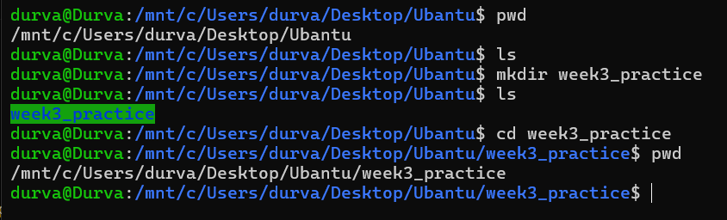

Exercise 2: File Creation and Management
Objective: Demonstrate basic file creation, copying, moving, and viewing commands.
Commands Used:
touch
cp
mv
cat
Expected Outcome: The user should be able to create a file, copy or move it, and view its contents.
Evidence:Ubuntu terminal showing file creation, content viewing, copying, and renaming using touch, cat, cp, and mv.
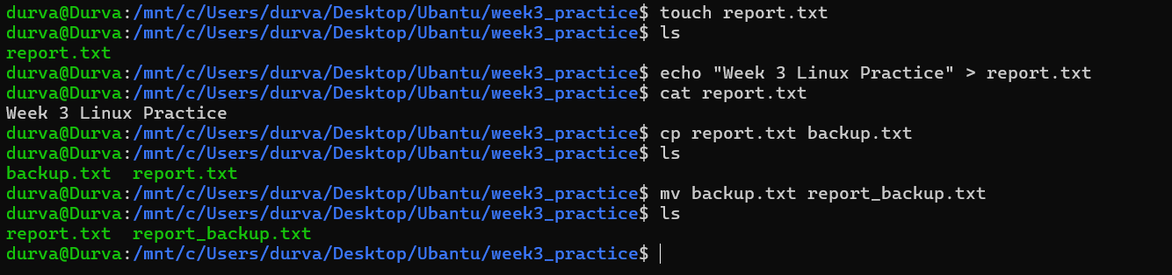

Exercise 3: File Permissions
Objective: Demonstrate how Linux file permissions can be viewed and modified.
Commands Used:
ls -l
chmod
chmod 644 report.txt
Expected Outcome: The user should be able to view existing file permissions and modify them using chmod.
Evidence: Ubuntu terminal showing the use of ls -l to view file permissions and chmod to modify permissions for two files.
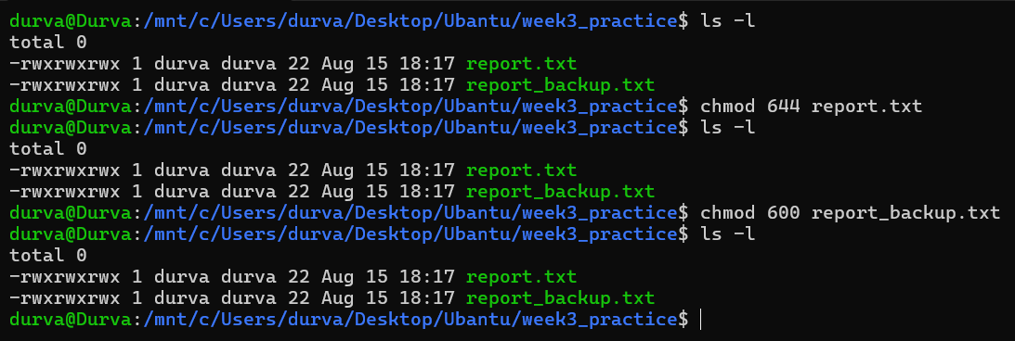

Exercise 4: Users and Groups
Objective: Demonstrate basic commands used to identify users and view group membership.
Commands Used:
whoami
id
groups
Expected Outcome: The user should be able to identify the current account and view its user and group information.
Evidence:Ubuntu terminal showing the current user identity and associated user and group information using whoami, id, and groups.
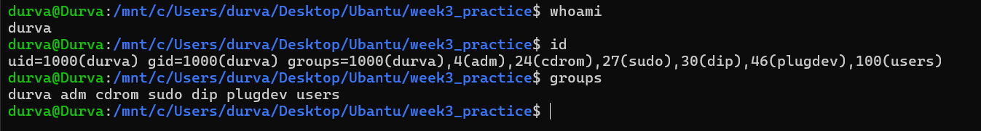

Exercise 5: Processes and System Information
Objective: Demonstrate basic commands used to view running processes and system information.
Commands Used:
ps aux
uname -a
df -h
free -h
Expected Outcome: The user should be able to view running processes, basic system information, disk usage, and memory usage.
Evidence: Ubuntu terminal showing running processes and basic system information using ps, uname, df, and free.
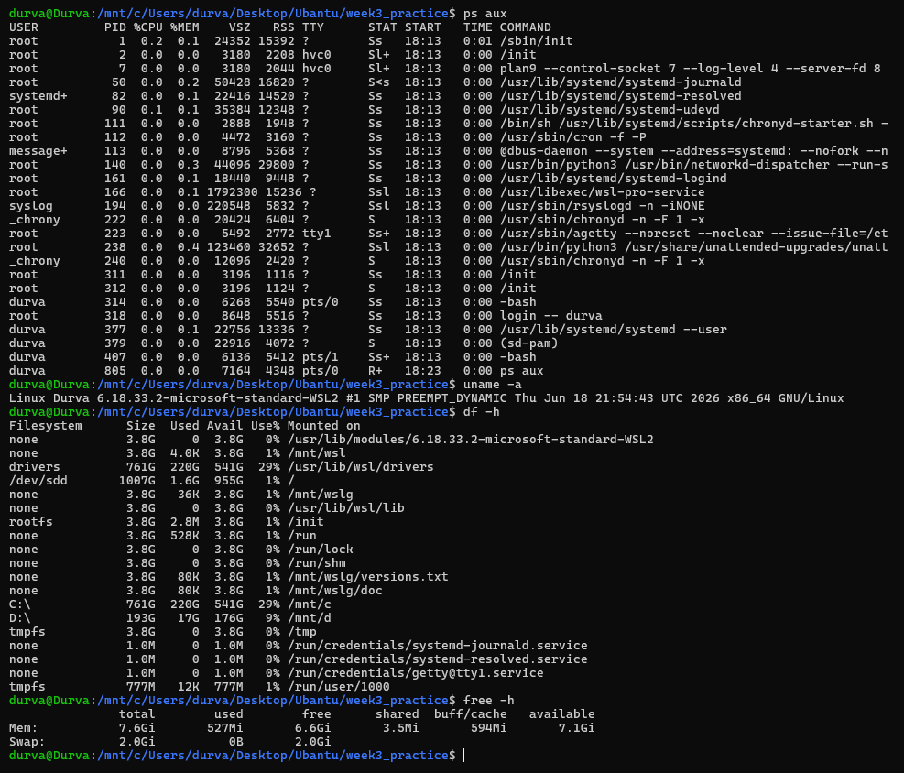

Conclusion
This handbook provided an introduction to Linux operating systems, file systems, users and groups, file permissions, common Linux commands, processes, logs, and basic security controls. The practical exercises demonstrated basic Linux command usage and reinforced the importance of access control, permissions, system updates, firewall configuration, and logging in maintaining system security.

The knowledge gained from this exercise provides a foundation for understanding Linux systems and their relevance to cybersecurity and GRC activities.

Version History
Version | Date | Author | Changes
1.0 | 15 August 2026 | Durva Amin | Initial Release

References
- Ubuntu Documentation – Used for understanding basic Ubuntu/Linux concepts and system administration.
- Linux Manual Pages (man pages) – Used as a reference for Linux commands and their usage.
- Microsoft WSL Documentation – Used for understanding and working with Ubuntu through Windows Subsystem for Linux.
- Week 3 Learning Notes – Personal notes prepared during the study of Linux operating systems and security concepts.

